
Student Manual

Advanced Skills for the
Practical Trainer

Table of Contents

Session One: Course Overview 1
Session Two: Preparing to Learn 2
Pre-Assignment Review 2
Individual Reflection 3
Session Three: Understanding Learning 5
The Trainer’s Role 5
Personal Skill Identification 6
Session Four: Competencies for Adult Educators 7
Questionnaire 7
Small Group Debrief 9
Session Five: Accommodating Learning Preferences 10
The Learning Process 10
Preparing a Plan 13
Learning Styles 15
Session Six: Increasing Your Expertise 20
Learning and Motivation 20
Design Considerations 21
Changing Points of View 23
Session Seven: Using Existing Materials 25
Customizing Courseware 25
Copyright Considerations 27
Over-Plan and Over-Prepare 28
Session Eight: Managing the Stress of Training 29
Easy De-Stressing Techniques 29
Building Resilience 31
De-Stressing in Class 32
Session Nine: Planning a Workshop 33
Preparing the Essentials 33
Planning for Success 34
Anticipating Challenges 36
Session Ten: Preparing Visual Aids 38
Session Eleven: Your Role as an Effective Communicator 40
Leading a Discussion 40
Small Group Work 41
Session Twelve: Questioning as a Training Technique 42
Session Thirteen: Kirkpatrick’s Levels of Evaluation 44
Level One: Reaction 44
Level Two: Knowledge Evaluation 50
Level Three: Transfer of Learning 54
Level Four: Impact Evaluation 55
Skill Application 58
Session Fourteen: On-the-Job Support 59
Session Fifteen: Dealing with Difficult Situations 60
Session Sixteen: Training in Different Forums 62
In Person or Not? 62
Limitations and Considerations 63
Session Seventeen: Team Teaching 65
What is Team Teaching? 65
Co-Facilitation Inventory 66
Session Eighteen: Training Preparation 68
Session Nineteen: Training Presentations 71
Personal Action Plan 72

Session One: Course Overview
Course Overview
Behind every spectacular training session is a lot of preparation and meticulous attention to detail. The truly skilled trainer can make a program exciting. The learners will have fun while they are learning if the facilitator is able to involve their emotions as well as their minds. You will see the involvement, and you will feel the energy.

To reach this stage as an adult educator isn’t always easy, but success isn’t just for the naturally gifted. It is possible for all of us who put effort into our personal growth and development. We want the enormous satisfaction that comes from working with others to help them reach their potential as human beings. This three-day workshop will help you reach that goal.

This workshop requires that you have a good understanding of basic training principles, including adult learning concepts, experiential learning cycle, training methods, and designing a learning sequence. We strongly recommend completing Edgewater The Practical Trainer workshop before taking this course.

Learning Objectives
At the end of this workshop, you will be able to:
- Demonstrate your understanding of learning styles and how to accommodate all four learning styles in the classroom
- Apply the key principles of effective communication in a workshop setting
- Use a variety of training techniques to stimulate participation
- Develop a plan and prepare for an effective training session
- Explain the different levels of evaluation and when to use each
- Identify advanced interventions for difficult situations
- Put your skills to work for a team presentation

Personal Objectives

Session Two: Preparing to Learn

Pre-Assignment Review
My Topics

Partner’s Name

Individual Reflection
As I think about my most successful experience as a trainer, I remember…

What I like most about being a trainer is…

My favorite instructional technique is…

What I find most difficult about training is…

What I most want to gain from this workshop is…

Session Three: Understanding Learning

The Trainer’s Role
Learning occurs everywhere in organizations, wherever employees face problems, deal with unforeseen issues, incorporate new systems and tools, or maneuver their way around obstacles to get their work done.

Learning can happen in two ways. In classrooms and in many training programs, teachers are responsible for evaluating curriculum and then determining the content they present. They impart this information to those who are there to learn.

In a more self-directed type of learning, the learner has responsibility for his or her own learning and determines what they want to learn. The teacher is more of a facilitator.

What implications does this have for those of us who have a training role in or for organizations?

Case Study
Susan, a human resource manager, knew she was uncomfortable around people she did not know, or if she did not have business to conduct. She found small talk really stressful because she never knew what to say. She enjoyed working with people at her job and couldn’t understand why she felt this way until she had the opportunity to complete a temperament assessment. Learning that she was a strong introvert helped her find techniques to overcome her initial discomfort in informal situations.

Personal Skill Identification
Based on your own experience, identify what you feel are the top five skills required to be a top-notch trainer.

Describe how you feel people can acquire those skills.

Session Four: Competencies for Adult Educators

Questionnaire
Fill out the questionnaire below.
- Place an “R” at each competency required for performing the role you are in or are preparing for.
- Place a “P” at those competencies you have now.
Competency Questionnaire
 | Description | R/P
 | Ability to describe an average adult learner in terms of needs, interests, motivation, capabilities, and developmental characteristics, and to apply that information to training.
 | Ability to describe the difference and similarities between children as learners and adult learners, and the implications of these differences for teaching and learning.
 | Ability to assess the effects on learning that external forces such as groups, organizations, and communities can have on learners.
 | Ability to describe the four stages of adult learning and to assess the impact they may have on particular adult learning situations.
 | Ability to conceptualize and explain the role of teacher, facilitator, and instructor.
 | Ability to feel comfortable in the combined roles of trainer, teacher, facilitator, and instructor.
 | Ability to establish a warm, mutually respectful, facilitative relationship with learners.
 | Ability to create a physical and psychological climate of comfort, interactivity, openness, and trust.
 | Ability to engage learners to take on the responsibility for self-diagnosis of needs for learning.
 | Ability to engage learners in participating, sharing, and exchanging viewpoints, sharing responsibilities and decision-making with them as appropriate.
 | Knowledge of the rationales for selecting a variety of materials, methods, and techniques for achieving particular learning objectives.
 | Skill in using a broad range of materials, methods, and techniques and in inventing techniques to fit new situations.
 | Ability to involve learners (when appropriate) in planning, conducting, and evaluating learning activities.
 | Ability to accept feedback from learners and apply that feedback to create more meaningful learning opportunities for them.
 | Ability to use small group processes effectively.
 | Ability to design learning experiences that take individual differences among learners into account.
 | Ability to work effectively with various audiences within the organization to collaboratively plan training.
 | Ability to design and use promotion, publicity, and public relations strategies appropriately and effectively.
 | Ability to design and operate programs within the framework of a limited budget.
 | Ability and willingness to experiment with program innovations and to assess their results.

Small Group Debrief
From this self-analysis and group discussion, what do you believe are the critical skills for you to focus on if you want to enhance your facilitation skills?

Session Five: Accommodating Learning Preferences

The Learning Process
While adults learn continually, they also demonstrate clear preferences about how they learn. Theorists have been considering how people learn since we started teaching people to read and write, and sometimes we do better with education than at other times. We like the work pioneered by David Kolb, who founded Experience Based Learning Systems and pioneered an Experiential Learning Cycle to reflect the way adults learn.

We have enhanced that knowledge with what we have learned about temperament and the rapid, demanding, always evolving environments we find ourselves working in. While it may be tempting to try, the Experiential Learning Cycle cannot be changed simply because an individual prefers one particular approach to learning or training. If effective, lasting learning is to occur, the entire cycle must be completed. What you will notice is that the learner will find themselves more comfortable (or engaged) in some activities than others. They are at their peak when they are operating within their comfort zone:

Using previous experiences to provide participants with an experience that furthers learning.

Often preferred by: Organized Guardians
Discussing previous experience or sharing reactions and observing the activity period.

Often preferred by: Inquiring Rationals
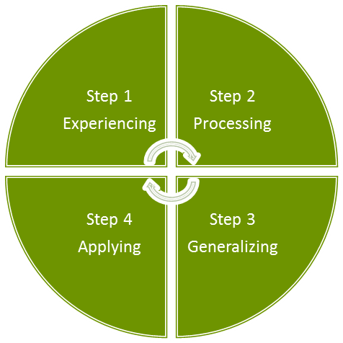/
Finding general trends and truths in the experience participants have already had or forming reactions to new experiences into conclusions, new concepts, and theories.

Often preferred by:
Resourceful Artisans
Modifying old behaviors or testing new ones and practicing them in realistic situations.

Often preferred by: Authentic Idealists

However, as we introduce a new teaching point, we also want to bring the participants on board with us, so we suggest an additional two steps before you start the four learning steps: Orientation and Objectives/Agenda.

For example, let’s say you want to teach people how to use a planner to schedule their daily activities.
Orientation
Do a little warm up to the idea of using a planner. You could ask how many people in the room use a planner. Do they prefer paper or electronic? How many buy them or have one or more electronic versions, but then never use them? Ask how many people just use their planner to keep track of meetings.
Objectives and Agenda
Explain that the objective is to use any planner effectively. We will work with a sample planner, and then develop some guidelines for selecting and using a planner.

There is a rule of thumb we can use when we are getting started at scheduling. If a task will take less than 30 minutes, do it. If the task takes more than 30 minutes, schedule it.
First Stage of Learning: Experiencing
Now you are ready to take the group through an experiential stage of learning: an exercise on using that planner. Give each person two pages from a planner: a month-at-a-glance page and a daily page. (Typically you would use the current month or an upcoming month and a day in the next week.) As they work on the Month at a Glance, ask them to fill in important family dates, personal healthcare or development days, any meetings they know they will be attending, and any tasks that must be done, keeping in mind, “If the task takes more than 30 minutes, schedule it.”

Then, we’ll move onto the daily page: their day, as they know it to be. We suggest using the next day they are back at work. Are there established routines they will follow, such as checking e-mails? Are there activities or jobs that must be done? How long will each job take? Are there people they must call? That daily page usually has room for scheduling, as well as your to-do list and the people you must contact. This can be documentation for what you do: a good enough reason in and of itself to justify using a planner.
Second Stage of Learning: Processing
Give people some opportunity to think about what they have just experienced and jot down some notes on what worked/what didn’t work for them. This can be a reflection exercise and a way for them to think about what else they need to learn.
Third Stage of Learning: Generalizing
Now ask them to share their thoughts with two to three others in a small group and suggest some guidelines for the type of planner that will work best, or some guidelines you have found helpful for using a planner.
Fourth Stage of Learning: Applying
In this example, and in many other teaching points, application will not occur until they are back in their own workplace. However, an application for our example might be buying a planner. If people working through the exercise already have a planner or use a software program, the application would be using it effectively.

Preparing a Plan
Our Teaching Point

Introduction or orientation

Objectives and agenda

Concrete experiential activity that begins the learning process

Processing

Generalizing

Application

Learning Styles
The Authentic Idealist Learning Style
As an Authentic Idealist, you are probably best at the Experiencing and Processing steps in the Experiential Learning Cycle. You probably have the ability to view situations from many perspectives. For example, you may enjoy brainstorming and small group discussions. You also like to gather information and probably have broad interests.

To increase your learning power, you need to place emphasis on the Generalizing and Applying phases in the learning process. This means forming conclusions from your information, planning the application of these conclusions, and actually implementing them.

For example, after watching a role play or listening to a discussion, summarize your observations into clear conclusions. Then decide how and when to test these conclusions in your own situations. Establish criteria to evaluate if the new idea really worked. Do this at the end of every activity in which you are an observer.

To further increase your learning power, take a more active role in the workshop than you might normally choose. Volunteer to be in the role plays, or to lead group discussions. This may be uncomfortable at first, but it will give you an opportunity to experiment with your ideas.

You may find it useful to discuss workshop topics with someone who has a Resourceful Artisan learning style. This person will help you see possible conclusions and applications you might overlook. In turn, you may help them see information they might overlook, and develop more perspective.

You may have a tendency to concentrate on the human side of problems or topics or exercises. This reflects your ability to understand or to empathize with others’ feelings or points of view, but you may also have a tendency to avoid drawing conclusions about the quantitative or technical aspects of the situation.

Try to develop these skills:
- Collecting and analyzing numerical data.
- Looking for overall patterns in any feedback you get.
- Putting your own feelings aside for a moment and taking a more objective look.
The Inquiring Rational Learning Style
You are best at using the Experiencing and Generalizing steps in the learning process. If this is your style, you have the ability to create theoretical models (ideas that predict outcomes and descriptions of how different factors interact). You most likely enjoy inductive reasoning and distilling disparate observations into logical explanations.

To increase your learning power, you need to place more emphasis on the Applying and Experiencing phases in the learning process. This involves speeding up your learning cycle by moving into action sooner. For example, after watching a role play or listening to a discussion, think about ways to immediately apply your conclusions. Look for opportunities to test your new idea during the workshop and personally experience the results. This may require you to conceptualize smaller scale experiments, not the large scale efforts you may prefer.

To further increase your learning, be more aware of the feelings and reactions of individuals (including yourself). You may have a tendency to discount intuitive or emotional information. However, much can be learned from a person’s tone of voice, facial expressions, and other body language. Much of this data is preliminary in nature and hard to analyze in a logical fashion, but it provides an early indication about how things are going or if an idea has been understood.

You may have a preference for examining the quantitative or factual aspects of a situation. Your conclusions may be based primarily on policies, official relations, or formulas developed in other situations. This can cause you to be over-cautious about experimenting and miss opportunities for learning or taking risks. Since no two situations are exactly alike, try to put more effort into trying ideas, skills, or concepts. Your ability to deal with non-quantitative data will increase if you get involved in interpersonal activities (such as role plays, simulations, and discussions) more frequently. Take an active role and express your feelings. Others will do the same and this will give you experience handling this new form of data. Enter into discussions with people whose primary learning style is the Organized Guardian. Note the value they place on intuition as a decision-making device and how effective this can be.

Try to add these learning skills:
- Seeking and exploring possibilities
- Influencing others
- Being personally involved
- Dealing with the people side of issues you work on, particularly how to get the support of key individuals whose help you will need
The Resourceful Artisan Learning Style
You are best at using the Generalization and Application steps in the learning process. If this is your style, you have the ability to find practical application for ideas, concepts, and theories. In particular, you enjoy situations in which there is a single of best answer to a question or problem. You may usually assume that there is one best answer and use technical analysis to reveal it.

To increase your learning power, you need to place even more emphasis on the Experiencing and Processing steps in the learning process. This means placing a higher value on gathering and understanding non-quantitative information by looking at a situation from different perspectives. The result may seem to slow your learning process, but it will actually speed things up as you focus on learning the most important things.

For example, while watching a role play or listening to a lecture, you may be thinking about how the topic or technique applies to your situation. Before making a decision, however, try to get other people’s perspectives. Listen to their ideas, comments, and questions. You may discover that the situation has elements you weren’t considering. This may influence how you apply your learning.

To further increase your learning, try to take a less active role in the workshop than you might usually take. Spend some time really listening to others’ ideas. Try to see the world as they see it and to understand their feelings and values. Play an observer role from time to time and avoid making judgments or decisions about how well others are doing. Instead, try to understand why they are saying or doing something. This may lead you to new and useful information.

You will find it important to discuss workshop topics with someone who has an Authentic Idealist learning style. This person will see both questions and possibilities you might tend to ignore or avoid. You may help them see how to apply some of their ideas.

Try to add these skills:
- Listening with an open mind
- Gathering information
- Imagining the implications of situations

The Organized Guardian Learning Style
You are best at using the Applying and Experiencing steps in the learning process. If this is your style, you have the ability to learn primarily from hands-on experience. You probably enjoy carrying out plans and involving yourself in new and challenging experiences.

Your tendency may be to act on intuition and gut feel rather than careful analysis. When a thoughtful approach does not seem to be working out, you will be quick to discard it and improvise.

To increase your learning power, you need to place even more emphasis on the Processing and Generalizing steps in the learning process. This means collecting and analyzing more information about the results of your efforts. Your batting average in the trial and error method of learning will increase if you learn more than you currently do from each of your trials.

For example, when watching a role play, you may feel frustrated and prefer to be doing the plan yourself. Your tendency might be to think of how you would do the same activity better than the people doing it. However, to develop your Processing and Generalizing skills, you should examine other, less personal aspects of the situation.

Here are questions you might ask:
- What basic point does the exercise prove or disprove?
- What other information aside from your personal experience do you have that relates to the same topic?
- Does this exercise help you understand why certain techniques work (not just what the techniques are or how to use them)?

To further increase your learning power, try to take a less physically active part in the workshop than you might normally choose. Be more mentally active. Volunteer to be an observer in some exercises, not a doer. This will give you an opportunity to reflect on other people’s experiences and learn from their trial and error.

You will find it useful to discuss workshop topics with someone who has an Inquiring Rational learning style. This person will help you see information you might otherwise miss. They will also help you see the hidden logic and patterns in situations. You can often use this perspective to guide your intuition. In turn, you can help them see new possibilities and opportunities to try out their ideas.

You may have a tendency to concentrate on the urgent aspects of a situation, favoring immediate utility over long-term understanding. To increase your learning, keep notes on your experiences, analyze them, and look for patterns. In other words, look for the forest as well as the trees. Take more time to get other people’s perspective on what has happened (or what you are about to do) during the workshop.

The particular skills you want to add are:
- Organizing information
- Building conceptual models
- Testing theories and ideas

Session Six: Increasing Your Expertise

Learning and Motivation
We’ve still got plenty to learn when it comes to adult education, how people learn, and how best to prepare teaching materials that they will relate to and remember. We haven’t learned everything when it comes to the ideal conditions for effecting a permanent change in a learner’s behavior, but we will certainly continue to try!

There are master trainers who pass along their favorite tips and tricks, but as Marshall McLuhan observed, “We don’t know who discovered water, but we can be pretty sure it wasn’t a fish.” In other words, master trainers may not always be the best good judges of what it took to turn them into master performers, just as a top performer doesn’t always make an ideal manager.

From a variety of sources there does emerge a body of fairly reliable knowledge about adult learning. This body can be divided into three basic ideas about adults in a learning context.
Things We Know About Adult Learners and Their Motivation
The first thing that we know is that adults generally look for learning when they are dealing with specific events. They want learning that is a means to an end and helps them to deal with something specific (such as a change at work or home, new tools or processes, new relationships, or other new challenges). Increasing or maintaining self-esteem and pleasure are strong secondary motivators for engaging in learning.

Design Considerations
The next two items apply to the design of the workshop.
Things We Know About Designing Curricula
Adult learners tell us that they prefer single concept, single theory courses that are practical and applicable to their problems. For example, they want to learn communication skills separately from how to use their new phone or computer.

They need to move through the learning cycle and integrate new ideas with what they already know. Information that conflicts with what they already know and hold to be true is integrated more slowly.

Curriculum designers should know whether the concepts and ideas will be in concert with or in conflict with learner and organizational values. (For example, in organizations where the pace is hectic, instilling a culture of reflection is often in conflict with organizational values.)

Some adults prefer self-directed and self-designed learning projects, rather than those led by a professional. This is in part because they can control pace and stop and start times. Self-direction is a highly desired state, and it does not mean isolation. In many instances, self-directed projects may involve up to 10 other people as resources, guides, encouragers, etc.

Technical media such as eLearning, reading books, podcasting, and television are popular methods of learning. They appeal to self-directed learners and people who have a hard time fitting large chunks of training into their schedule. However, they do not allow for shared experiences with other learners, practice of application in front of peers, or feedback from peers, which is important especially with soft skills learning.

Regardless of media, the adult learner wants a straightforward “how to.” Being able to apply learning is important.

In addition, lectures and seminars tend to get high ratings when learners can have face-to-face interaction with an expert.
Things We Know About the Learning Environment
Let’s talk about things we know about working with adults in the classroom and other learning environments. The learning environment has to be physically and psychologically comfortable.

Some learners view classroom situations as a risk. Some activities, questions, and/or role plays may make them feel insecure, or as though their self-esteem and egos are on the line. Create a learning environment where they feel safe stepping outside their comfort zone.

Adults have expectations, so it is critical to take time up front to clarify everybody’s expectations. For example, at the beginning of a workshop we can establish ground rules and share objectives before the course gets underway.

Adults bring a lot of life experience into the classroom. This is an asset to be tapped and used by asking questions, creating small group discussions, including peer teaching, and so on. As trainers, we need to include sharing and discussion time in the program design.

You might have heard the old saying, “You can lead a horse to water, but you can’t make him drink.” The same is true of people and learning. Adults can’t be threatened, coerced, or tricked into learning something new. They can be ordered into a classroom and prodded into a seat but they cannot be forced to learn.

Although trainers are often faced with adults who have been sent to training, there are some insights to be gathered from the research on adults who seek out structured learning experience on their own, like you probably did when you registered for this workshop.

Changing Points of View
As trainers, we are constantly reviewing the work that we do and looking for ways to do what we do even better the next time. We can help ourselves by looking at the session from a different point of view. Right now you are a participant, and so you have most likely been considering this course as a learner. Perhaps you have been thinking to yourself, “What am I learning? What can I take back from and use in my work?”

Now, we’re going to encourage you to look at this course from the designer’s perspective. Consider what has been happening in our learning environment.

What training techniques have been used?

What trainer/facilitator skills have you noticed?

Is the learning cycle being applied?

Did the trainer establish an environment that is conducive to learning?

What’s working well?

What would you change if you were the trainer?

Session Seven: Using Existing Materials

Customizing Courseware
There are numerous options for creating your training materials. One is to research, write, edit, test, and implement a program that you write yourself. This is often an excellent way to meet the needs of your participants, but it does take a significant amount of time. The ASTD (formerly called the American Society of Training and Development) estimates that it takes about 40 hours to develop each hour of training time. We find this to be accurate in the development that we do, which translates to 280 hours required to create a seven hour training day.

(Sources: http://www.astd.org/LC/2009/0809_kapp.htm and http://www.astd.org/ASTD/aboutus/trainingindustryFAQ.htm)

On the other hand, there are companies that do an excellent job of creating materials that are current, rich in content, and give you permission to customize upon purchase. Imagine the impact of offering a course to your clients or employees that you have been able to target very specifically to them, but after only a few hours of customization.
What Does It Take To Customize A Program?
Step One
Complete a needs analysis for your client or employer to determine exactly what the training needs are.

Step Two
Research and consider the materials available by conducting a web search. For example, if your needs analysis identified that the group would benefit from training on conflict resolution and dealing with difficult people, either call your courseware provider that you normally deal with or do an Internet search. Check the outlines and learning objectives that are listed online, speak with the vendor(s), and make sure you check to see if you can customize their materials under the purchase or licensing agreement.

Step Three
If you are using pre-built courseware, order your materials! Once you have them (or download them), review them and see if there are any gaps between what’s available and what you identified in the needs analysis. Sometimes very little customizing is needed; you may want to insert the department name, or company, or simply tweak exercises to reflect your industry. Or, you may want to take things further and create case studies that are very specific.

If you’re starting from scratch, it’s time to research, write, edit, and if possible, test the materials before you have to deliver them. The bottom line is to make sure you are comfortable with what you are presenting.

Step Four
Prepare for your training session(s) and take it away!

Step Five
Afterwards, evaluate the course that you presented, and make notes or any adjustments for the next time you deliver the course.

Copyright Considerations
When you purchase customizable materials, check the licensing agreement carefully. Just because you customize it, you do not then own the copyright for the materials. Usually, copyright stays with the company where the material originates. This includes your obligation to keep their copyright statement at the bottom of each page (see the footer below, for example).

Note as well that just because you customize material, or because you have a license to customize those materials, you do not necessarily have permission to publish them (in print form or on the Internet) as if you had written them. Always ask permission to publish from the copyright holder and make sure that you put the permission statement clearly with the published work (including web pages). As trainers, we often want to make our visuals appealing. We want to use pictures, clip art, and features that bring the material to life. When you include those visuals, make sure that you check the licensing agreements to ensure that you can use them in your training in the country where you are working. Copyright rules are quite strict and you want to demonstrate integrity in the work that you do to add to your credibility as a trainer.

Over-Plan and Over-Prepare
One of our in-house trainers tells the story of a new trainer who was ready to deliver a 3-hour training session as one of her first forays into public training. Within 45 minutes, she was starting to panic, because she had already run out of material and didn’t know what to do.

We can read an example like this and have a little chuckle. Sometimes we are simply joyful that it happened to someone else, but not to us! The reality is that it happens more than we want to think. New and inexperienced trainers often plan according to all the steps that we teach in training, but they do not over-prepare.

The opposite (but equally alarming failure) happens when we get to the end of a seven hour day and realize you need another seven hours to cover all your material.

You can build a few safety mechanisms into your training to ensure that you meet the training objectives and that you keep your participants fully engaged. Some ideas:
- Plan for a few extra activities that will assist with the objectives and allow you to stretch time if you need to. These might include language-based activities like word games related to the content, brain teasers, quizzes, or discussions.
- Time yourself. Often, we design our training and include a time period (typically 15 minutes) to a session. But if the content or methodology is new, we don’t really know how long it will take to deliver unless we have been delivering training for a long time.
- Practice at least some sessions in front of a few colleagues, a mentor, or even your family. Record yourself and listen to see if you sound rushed or too laid back, and to get a sense of how long something will really take.
- Practice will also help you get a sense of your pacing and the length of time that is actually required for different types of activities.

Session Eight: Managing the Stress of Training

Easy De-Stressing Techniques
Stress can be positive and negative, but too much negative stress can take a toll on our mental and physical health. When we channel the energy from stress in positive ways, we can accomplish things that we never imagined. When a lot of negative stress builds up, we can have trouble getting our work done, feel unusually tired, and lose our usual motivation. If stress seems to be wearing you down and you are having trouble bouncing back, you may need to consult your doctor. However, for the usual day to day stressors that we encounter, here are some quick, easy ways you can lower your stress levels quickly.
Deep Breathing
Loosen your clothes, close your eyes, mentally relax your body, and take ten or more deep breaths. Your goal is to breathe into the bottom of your lungs (where the oxygen is readily absorbed), not the usual upper lung breathing we do. Put your hand on your stomach and feel it move as you breathe in in order to make sure you are getting the air in good and deep. We call this diaphragmatic breathing because you are using your diaphragm muscle to breathe. When people are experiencing anxiety they are most often breathing into the upper area of their lungs rather than the bottom.

Each time you exhale, count silently: “one,” after the first breath, “two,” after the second breath, etc., up to at least ten. If you lose count, or find yourself working on thoughts as they pass through your mind, start your count over again. When you are finished, you should feel more calm and relaxed. (Your blood pressure will go down temporarily, too.) If you’re around other people, count in your head.
Visualize
Use positive imagery to boost your mood and enhance your visible performance. In your mind, picture a place that you love. Feel the sunshine on your face, or the breeze on your skin. See the things that you enjoy in great detail. If you are getting ready for a presentation or an interview, visualize yourself performing it perfectly, so that when you get to the event your mind thinks you’ve done it before. (This is a technique used by athletes and peak performance coaches.)
Music
Music has the power to soothe or to give us energy. It actually has healing power, too. Find a type of music that relaxes you, and play it when you need to calm down. When you feel tired and listless, play some rousing music (rather than relying on caffeine or other stimulants) to give you a pick-up.
Acupressure and Massage
Holding a fingertip to the point of most pain or tension and pressing very hard into the offending muscle for up to a minute can avert a headache or relieve tension. Have a friend or spouse learn how to do massage therapy and/or acupressure on tense muscles, since daily treatment is better than once or twice a month.
Laughter
Laughter is the best medicine of all. A good belly laugh can lower blood pressure, slow your adrenaline, and reverse the stomach acid that comes with negative responses. Be on the lookout for jokes and cartoons you can share with family and friends. For a smaller dose, find a cartoon or picture that always makes you smile and post it near your desk. (Just make sure it’s appropriate for all audiences!)
Replace Worry with Problem Solving
Focus on what you can do, and then go ahead and do it. Chronic worriers tend to focus on what they cannot do, what should be happening, or how things are going wrong. Replace worry with problem solving so that you identify where you can step in. Then, stop waiting for the perfect time and just get on and do it.
Meditation
The purpose of meditation is to free your mind from its normal busy activities. There are several different techniques that can be used. Some people use a word as a focal point (a mantra), while others suggest you focus on a color, your breathing, an abstract concept, or an object.

Here is a good process for meditation. Sit quietly with your eyes closed and relax all your muscles from head to toe. Become aware of your breathing. Breathe through your nose easily and naturally, in and out… Begin to silently repeat the word you have chosen or focus on the color you have chosen. In and out… Let distracting thoughts pass through your mind. Continue doing this for 15 to 20 minutes.

Building Resilience
Each stressful experience that you have prepares you to deal with one in the future. The more resilient you become, the less of an impact each of these events has on your mind and body. Lots of us go to great lengths to avoid stress, and although avoidance initially feels like you are doing alright, the reality is that stressful things come up in our life all the time. The better we are at handling them, the more resilient we become, and the healthier we can be.

Each stressful experience can lead us into a cycle of confusion and even anguish. If we stay with those feelings, however, things actually get worse. But if we make a decision to deal with those circumstances by problem solving and adapting, we develop resilience. This means that we can enjoy life more and be more successful.

As you encounter more stressors in life (and we all do), we can rely on the experience we’ve had in dealing with negative circumstances in order to cope. We get more effective at managing that cycle of confusion and anguish, problem solving, adapting, and moving on.

As a trainer, you will not just have to deal with your own stressors and reactions to them, but also those of your participants. One tip for you is to have several exercises in your standard toolkit that are effective at lowering stress levels in your class.

Why is it important to reduce stress levels in the class?

What kinds of things will increase participants’ stress levels?

De-Stressing in Class
Create a quick de-stressing exercise or energizer for your own training toolkit. You need to plan something quick and active. You should also include a debrief at the end of the exercise. This could be an activity that you create yourself or have experienced in other workshops.

Session Nine: Planning a Workshop

Preparing the Essentials
Psychology research tells us that an adult’s attention span is a little less than an hour. However, we also know that attention spans are getting shorter. Bob Pike, a master trainer in America, said that some years ago his team redesigned their training to change activities about every fifteen minutes. Then they adjusted down to ten minutes, and now they are at about seven minutes, which roughly matches how often a television show breaks for commercials.

What significance does this have for us as trainers or facilitators?

We must break up our training day into manageable segments if we want to keep people’s attention. Since many learners come to us interested and motivated to learn, we can probably be safe by preparing longer segments (no more than 15 minutes). This does not mean that you have to change subjects every segment, but it does mean that you have to engage people at least that often: ask a question, use a gesture, start an activity, etc.

Giving a workshop isn’t like stopping by somebody’s desk to chat with them. There are risks. There are expectations. You and the knowledge you bring to the session are exposed for every participant to see and judge. While your workshop is an event in and of itself, learning is not an event. Learning is a process that unfolds over time, and our training has to reflect that. Approach every workshop you deliver as a project.

Preparation involves these activities:
- A needs assessment
- A determination of what you are to cover and in what detail it needs to be covered
- How much time will be allotted to the training
- How and when participants will be informed that the training is taking place

Sometimes this will be done for you, yet you still will want to know these details yourself. The needs assessment is the most important as it will identify the objectives of the training session, and may provide the other details, too. That is the basis for the preparation from here onward: making certain the training meets the objectives that have been identified.

Planning for Success
There are six components to any training plan.
Who?
There are several people that you may need to speak with in order to prepare a thorough training plan, including:
- Participants
- Supervisors
- Senior managers
- The person who has requested and/or is paying for the training
Why?
Next, we will set objectives, the reasons for doing the workshop and the desired outcomes. The steps for this are:
- Seek input
- Determine whether objectives are doable
- Prioritize in order of importance
- Organize materials to support objectives
What?
Next, think about the content; the agenda or learning points to be covered. The material will be influenced by several factors, such as the trainees’ motivation to attend training (was it their own idea or a mandatory course?), their learning style, and the trainer’s preferred training style. Other factors will include available resources, time available, and the trainer’s skill level.
How?
Once you know what you are going to train, you need to determine how to present it. Here are some ideas:

Methods and Activities | Structures
- Rounds  - Brainstorming  - Video  - Role play  - Problem solving  - Group discussion  - Demonstration  - Case study  - Other | - One on one  - Small group  - Large group  - Pairs  - Individual work

When choosing your training methods, don’t forget to keep learning styles and objectives in mind. You want a varied approach that will teach the material required in an engaging manner.
When?
Now, think about timing.
- How long will your workshop be?
- How long will each segment of your workshop be?

The depth of content you can provide will depend on how much time you have and training priorities.
Bringing it All Together
Finally, assess the learning plan:
- Objectives
- Methods
- Timing
- Quality
- How it feels

Make revisions and repeat the process as necessary to complete your training plan.

Anticipating Challenges
Being Prepared
Every group will present its own challenges. As well, you will find yourself delivering in a slightly different manner if you have five people than you might if you had 15 or 50.

Whoever they are and however many they are, you will want to have some idea of how they feel about the training. It will help if you know the answers to these questions:
- Who are the people in the group? Male or female or both?
- Do you know them? Do they know each other?
- How long have they been with the organization?
- What job function and level of seniority do they have?
- What previous training have they had?
- What are their language levels like? (Are they fluent in English, for example, or learning the language? If learning, what stages are their oral, written, and reading skills at?)
- What will be their attitude toward the training? What are their expectations? (Whenever possible, ask this of their managers as well.)

You can never know too much about the group you are about to work with. Information helps you avoid unpleasant surprises and helps you adjust your plan before you are standing in front of an audience.
What might you do differently if you have someone in your group who cannot speak your language of instruction?
This can be difficult if there is nobody in the room who can act as translator. However, these things can help:
- Lots of illustrations or videos as training aids
- Pairing this individual with different people during the day so everybody shares the communication challenge
- Working one-on-one with them after class
What might you do differently if you have someone in your group who is legally blind?
Most legally blind individuals have some sight. If this is the case large, legible lettering on flip charts or PowerPoint. If the visually impaired person can hear, learn to describe what others are seeing and read questions from the manual before assigning them. Most importantly, remember to ask them what will be most helpful.
What if you have someone who is severely disabled?
Generally individuals who are severely disabled with have an attendant in the classroom with them. Ask both the individual and their attendant what will be most helpful to them.
What if you have someone who has a limited ability to read or write?
People with low literacy levels are usually very fearful of even coming to a workshop. They want to avoid humiliation at all costs. Sometimes you can overcome obstacles by:
- Spending more time in open discussion and less time on individual exercises
- Reading or repeating questions before people form discussion teams
- Pairing the individual with a buddy who is aware of the difficulty and can work with them

Session Ten: Preparing Visual Aids
PowerPoint Slides
PowerPoint slides are one of the most popular presentation and training tools in use today. They are easy to create and update, and most programs make it easy to generate instructor and student notes. They are also reusable and efficient.

However, there can be too much of a good thing. To make sure your PowerPoint slides work for you, keep these tips in mind.
- Use a consistent theme (colors, fonts, and styles).
- Make sure you use a large font.
- Keep graphics and animations to a minimum.
- Use a projector rather than showing the slides off your computer screen.
- List talking points on the slides – don’t read off of them.
- Practice, practice, practice!

Also, make sure you always have a backup plan, such as a printout of your slides that you can transfer to flip chart, whiteboard, or overhead.
Video (Digital, VCR, or DVD)
Videos are another popular training tool. They are portable and easy to use. However, although they can be stimulating, audiences tend to drift off if they are too long.

As a solution, make sure you preview the video to make sure it is of the appropriate quality and length. You may want to cue up certain portions, rather than showing the whole thing. You may also want to develop an exercise (such as a role play, case study, or discussion sheet) for participants to complete after the video.

Once again, make sure you have a backup plan in case the video equipment is missing or broken.
Flip Charts
You will find flip charts in almost every training room. Although they are flexible and easy to use, they are too small for more than 20 people. To ensure your flip chart is readable, buy lined paper, or lightly draw lines in pencil before the workshop. You can also pre-write some pages and tuck them away for when you need them. As well, you can remove and tape up different pages of the flip chart for reference throughout the session.

When writing on flip charts, make sure you use dark blue, black, or brown ink for writing. Save the brighter colors for highlighting and arrows. As well, use the top two thirds of the page only, to make sure all participants can see the information.

Make sure you have plenty of paper, tape, and extra markers available.
Whiteboard or Chalkboard
Whiteboards and chalkboards are also inexpensive, flexible, and easy to use. Chalkboards are less commonly used, since they are messy and some people are allergic to chalk.

For either method, make sure you write clearly and in large letters. For the whiteboard, remember the same color guidelines as for flip charts (blue, brown, or black ink for writing; brighter colors for highlighting or drawing).

Make sure that you have plenty of chalk or markers and several erasers handy.
Smartboards
These electronic whiteboards are installed in many classroom and conference rooms. They allow you to write electronically by using a keyboard (or hooking up your laptop) and making notes like you would on a flip chart. This format allows you to highlight information, display slides or graphics, and conserve paper.

To ensure that your presentation is professional and effective, make sure that you know how to properly use the board before your session starts. One issue that we have come across is that the smartboard is often mounted on the wall directly behind the projector screen, making it very difficult for the trainer to switch back and forth between the two. They are also sometimes quite small, making them difficult to use with large groups.

Session Eleven: Your Role as an Effective Communicator

Leading a Discussion
Communication, or the transfer of a message, is an essential part of any learning situation. In communication, we impart knowledge, express opinions, share feelings and discoveries, report views, and agree or disagree with others.

Because it usually rests with the trainer to trigger the communication process, and because the quality and depth of the communication depends to a large extent on his/her skill, you will want to develop your ability to carry on discussions that get everyone involved.
Leading a Discussion
Good discussions require more than simple questions and answers. When done properly, discussion is an extremely valuable method of learning and instruction. In fact, it is the most common technique used to get learners involved and participating. However, discussion leaders need skill and style to maximize learning.

Every leader will eventually develop a style or a way of doing things. You probably already have a sense of your style. What is right for one person may not be right for another. One person might use more control with the group; another may prefer a low profile that allows him or her to stay in the background. Whatever style you choose, remember that your main responsibility as a discussion leader is to guide, involve group members, and summarize the ideas presented.

Your role should be based on your skill and ability to listen constructively, to question skillfully, and to coordinate the contributions of each individual.

Small Group Work
What are some ways you might begin a discussion?

How do you encourage full participation and free discussion?

What can you do to keep the group on track, yet not cut off people who go on tangents?

What are some of your greatest challenges as a discussion leader?

Session Twelve: Questioning as a Training Technique
A great deal of communicating is done by asking questions. Questioning sometimes implies doubting, but for trainers and facilitators, it can mean:
- Requesting information in order to gain knowledge
- Seeking clarification
- Establishing facts
- Satisfying curiosity

You as the trainer want to make learning more effective and meaningful. To do this, it is necessary for both the trainer and trainees to develop questioning techniques that facilitate free discussion and expression of feelings and ideas.

The ability to use questions effectively can also depend on having an ear for hidden meanings. For example, a participant may begin a conversation with a statement that is easy for them to make, but which doesn’t really address what is on their mind. Sometimes they haven’t admitted to themselves what the problem is, or they themselves may honestly not know.

For example, let’s say that a participant complains about the lack of organization at a session, in that the group didn’t break for coffee at a fixed time. A non-directive question (“You feel this unstructured format is a bad thing?”) may bring out the feelings behind the complaint.

Let’s look at some types of questions that trainers can use to improve communication.
Types of Questions
Leading Questions
These questions contain the correct answer. They can be used to draw out the shy or quiet individual and to guide the learner toward the correct answer. Example: “You can see the advantages of working together on a project, can’t you?”

Factual Questions
The questions ask the student to give the what, where, when, why, and how. Examples:
- How many times a day would you use a lecture format?
- When would a lecture format be most helpful?
Problem Questions
These stimulate and challenge the learner. The question may be used to set up a situation involving a number of factors and perhaps some controversial elements. Example: “When you have a group of young, restless males and they are no longer listening to the topic under discussion, what strategies can you use to keep them engaged?”

Attitudinal Questions
This type of question is used to bring out the feelings of the other person. Example: “If I understand you correctly, you feel we’ve taken too long to cover this topic? Do others feel this way too?”

Session Thirteen: Kirkpatrick’s Levels of Evaluation

Level One: Reaction
How do we know the training we just delivered was effective? Even if the participants seem happy as they walk out the door, and even if they give you high marks on the evaluation form that they hurriedly filled out before they left the room, this doesn’t give us a clear picture of whether they truly learned and whether they can use what they learned.

Educators generally use four levels of evaluation. The most common model is that developed by Donald Kirkpatrick in 1959. Since that time, Kirkpatrick’s work has been adapted worldwide. It continues to apply to the training environment today just as it did then.

Kirkpatrick’s model looks like this:



The first stage, reaction, is measuring the participants’ reaction to the program. Did they like you? Did they like the program? Were they happy as they walked out the door? This level of evaluation has sometimes been called “smile sheets.” It is sometimes dismissed as incidental to the true evaluation process.

However, they are more significant than they may at first appear. While liking a workshop or a facilitator does not necessarily mean participants learned, disliking a workshop or a facilitator (or the room, or the materials, or any other element of the learning process) can hamper learning.

Learning is sometimes a painful process, so we can use the information we gather from these reaction sheets to alert us to potential problems and to revise or fine tune our presentation style and our materials, if need be.

This level of evaluation can answer questions such as:
- Was the material appropriate for this group? Was it too hard or too easy? Did it focus on what they wanted or needed to learn?
- Was the course adequate for the group? Was there enough material or too much material? Did it cover enough of the topic or was there too much material covered too quickly?
- Was the course delivered efficiently for the group? Did participants spend time and energy on those topics that needed the time and energy?
Rather than wait until the end of the workshop when participants are leaving, you may wish to measure their reaction mid-course. This can act as a reality check for you and allow you to adjust and revise for the second half of the program.
Sample One
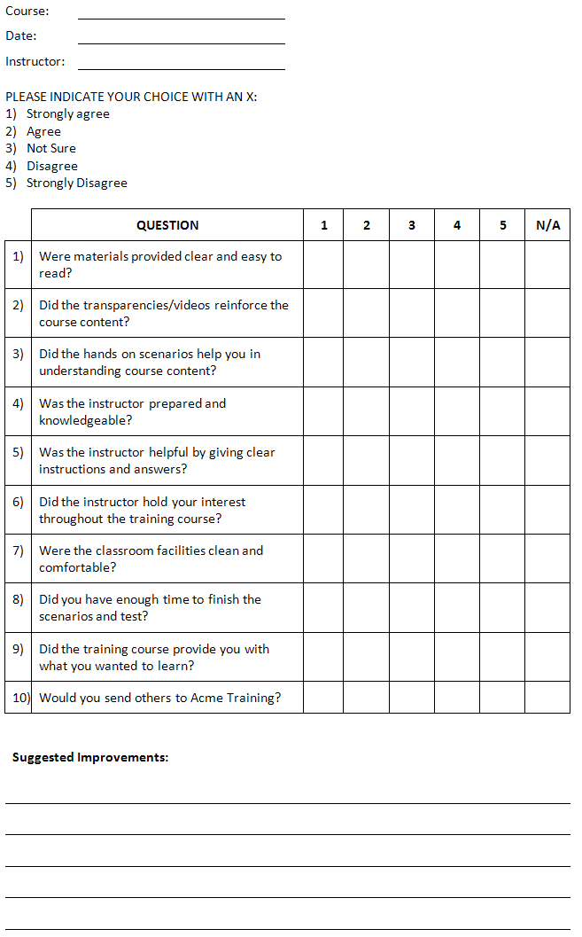

Sample Two
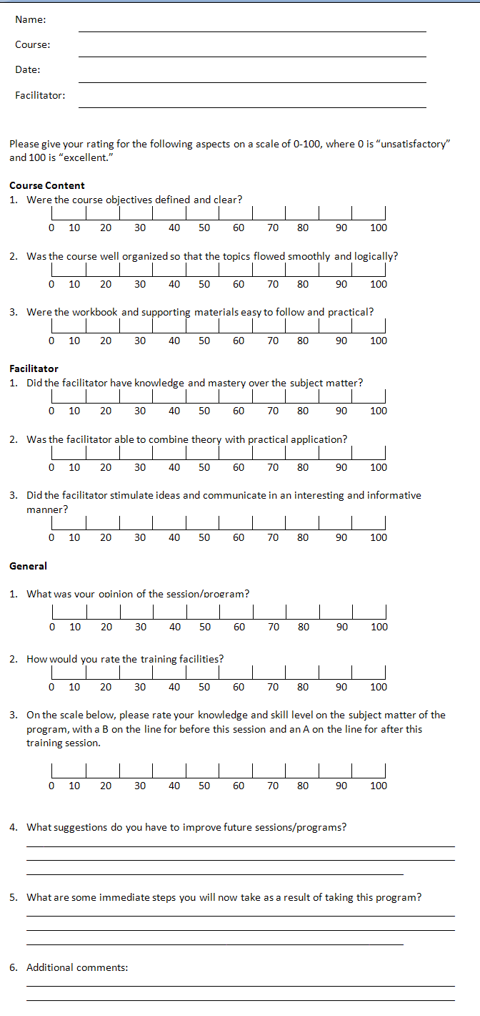
Sample Three
You can draw a five-point continuum on the flip chart and ask participants to respond to the several points on it by a show of hands.

How many feel there was too much stuff today?



How many feel the day went too fast?

How many feel the day went too slow?

Another way of using the continuum is to place it on a wall. The five degrees may actually be posted via flip chart sheets at five wall positions or just pointed to in a general way: "Strongly Agree is here;" "Agree is here;" etc. Then let participants position themselves physically, in relation to the five degrees, to indicate their reaction or feeling about a given evaluation question.
Sample Four
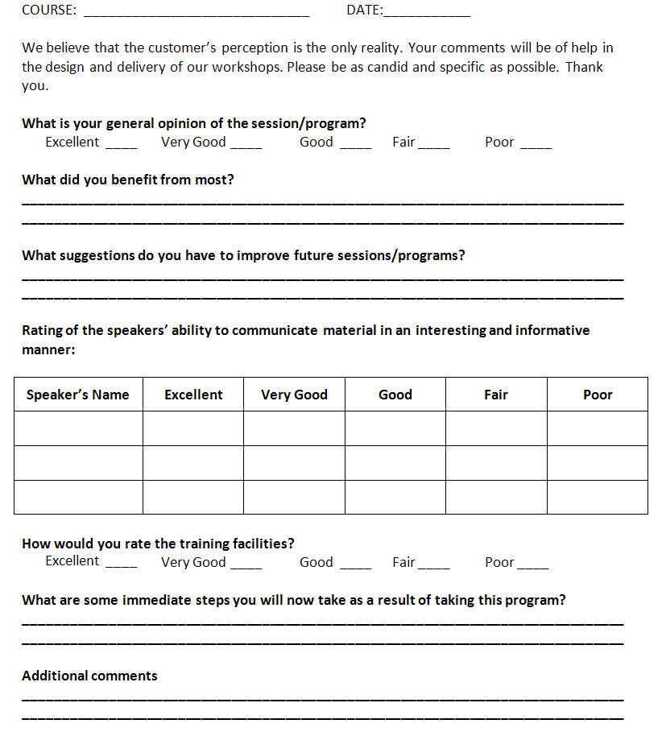

Level Two: Knowledge Evaluation
The second level is learning or knowledge evaluation. This is the heart of an evaluation strategy. Did the participants learn? Usually we can measure learning by determining whether the learning objectives have been met.

If the objective was an increase in knowledge, this can be fairly easily tested by a pen and paper test, just as teachers do in school.

If this was a skill to be learned, the test can be a post course performance test. For example, if the skill to be learned was using an electronic cash resister, they can demonstrate their skills in a series of situations. Or, you may want to ask them to complete a comfort level evaluation.

Testing for a change in attitude is more difficult. We can speculate about whether there has been a change, but actions will speak louder than words. Change in attitude is best measured after participants have returned to the workplace and have the opportunity to apply their new skills.

Samples of knowledge and skill of evaluations are shown on the following pages.

Sample Comfort Level Evaluation

Course: ________________________ Date: _____________

Please take a minute to indicate how comfortable you are with the skills you learned in today’s session.
Technique or Skill | Piece of Cake  I didn’t have any trouble with this and will be able to use it easily. | Let Me Practice  I’m catching on, but I need more practice time. | Show Me Again  I’m having trouble with this and need more instruction.
1.

2.

3.

4.

5.

Sample Pre and Post Test
Rating Chart |  |  | 1 = Fair |  | 2 = Needs Work | 3 = Good | 4 = Very Good | 5 = Excellent
For your pre-workshop exercise, please fill in the space on the right hand side. You will be asked at a later date to complete the score on the left hand side as a post-workshop exercise. Your ratings will not be shared with anyone.
 | Pre-Workshop  Rating |  |  |  |  |  |  |  | Post-Workshop  Rating
Role As A Member of The Management Team:
1 |  | Understand your role as a supervisor
2 |  | Maintain good working relationships with colleagues and senior management
3 |  | Foster quality consciousness in the work group
4 |  | Have effective ways to eliminate stress
5 |  | Be able to see the overall picture
 |  | TOTAL
Your Organizational Skills:
6 |  | Define work objectives so they are clear to employees
7 |  | Prioritize work to be done
8 |  | Handle details effectively so things don’t slip through the cracks
9 |  | Use a planner to schedule work
10 |  | Manage multiple priorities, projects, and assignments
 |  | TOTAL
Your Leadership Skills:
11 |  | Help others build self -esteem
12 |  | Manage a diverse workforce
13 |  | Use the technical, organizational, and human support available to improve job performance
14 |  | Establish and maintain high performance goals for the unit
15 |  | Be a role model for your employees
 |  | TOTAL

Your Communication Skills:
16 |  | Provide clear directions or instructions
17 |  | Use questioning techniques to collect information
18 |  | Encourage feedback from peers, work group, and supervisors
19 |  | Provide timely feedback on performances
20 |  | Really listen to what others are saying
 |  | TOTAL
Your Interaction/Team Skills:
21 |  | Develop work teams to prepare them for future responsibilities
22 |  | Understand and accept the potential of team work
23 |  | Build a climate for effective team functioning
24 |  | Work with people of diverse aptitudes and attitudes
25 |  | Recognize individuals for the contribution they make
 |  | TOTAL
Problem/Conflict Resolution Skills:
26 |  | Handle and resolve conflicts as they arise
27 |  | Be proactive in identifying potential problems
28 |  | Be creative when solving problems
29 |  | Recognize conflict as a positive element in a work group
30 |  | Follow up to see if solutions are really working
 |  | TOTAL
Pre-Workshop Score
Add your points for each category and enter here.

Mgmt. Team | Org. Skills | Leadership Skills | Communication Skills | Interaction/ Team Skills | Problem/  Conflict Skills | TOTAL

Post-Workshop Score
Add your points for each category and enter here.

Mgmt. Team | Org. Skills | Leadership Skills | Communication Skills | Interaction/ Team Skills | Problem/  Conflict Skills | TOTAL

Level Three: Transfer of Learning
Evaluating transfer of learning is more difficult, but often the most effective type of evaluation that we can do. Can and will participants use their learning back in the real world?

As an example of what we mean, imagine that you attended a workshop on managing conflict. You enjoyed the workshop (reaction) and you learned a great deal about what conflict is and how it should be managed (learning). However, the next time you and your partner are in a conflict, or you have two employees who are engaged in a conflict you must help them resolve, everything you learned went flying out the window. There was no transfer of learning.

Often, evaluating transfer of learning means collecting information from the participant, his or her manager, his or her customers, and even co-workers. Your goal is to determine whether there has been an impact on everyday life at work. This can be conducted in several ways, including a questionnaire, interview, or as part of a 360 degree performance evaluation.

When you send participants back to use these skills on the job, creating some type of support system at work can be very useful; this is best done in a partnership between you and the participant’s supervisor or manager.

Level Four: Impact Evaluation
The fourth evaluation level is whether all that training made an impact: did it make a difference if the employee was a more skilled customer service representative, sales executive, or supervisor? When training has been truly successful, there is a natural transition from learning a skill to owning a skill, and ultimately passing it on to others.

A direct business result is difficult to measure. For example, sales training may lead to an increase in sales. A workshop on safety may reduce accidents. Customer service training may reduce customer complaints. Even then, there are so many variables that it is difficult to measure impact of training in isolation.

When we consider the impact of training, we should also ask whether the training was appropriate, adequate, and effective.
- For example, perhaps the sales training increased sales yet at the same time elevated work-related stress. Thus, the training might not have been appropriate.
- If safety training reduced 7 % of the accidents when management was hoping for a 100% reduction, the training would not have been adequate. (Perhaps more time was needed for demonstrations or role play.)
- A drop in customer complaints may have been the result of effective training, or the drop might have been a result of a new billing system installed at the same time.

Watch out for other factors, such as where a manager acknowledges the value that training should have, and simultaneously increases expectations. When the measurements are taken, it could appear that training missed the new benchmark, where in reality improvements using the previous numbers were measureable and noteworthy.

Evaluation must begin as the training program is being put together.
- What is the training to achieve?
- What are the objectives of the training?
- How will these results/objectives be measured?
- Finally, what support is in place to ensure the training is put to use?

Sample Impact Evaluation for Participants

Would you please take a few minutes to help us measure whether this training program has made a difference for you at work.

Participant's Name:
Manager's Name:
Company Name:
Program Title:
Dates of Program:
Location of Program:

Have you seen a positive change in your skill level? If so, in what area(s) have these changes been most noticeable?

What are you doing differently now? Do you feel these changes are directly related to your training program?

Have you had any difficulty using the skills/knowledge covered in the course? If so, what difficulties have you experienced?

Do you have suggestions for additional or advanced training that you feel would be helpful to you?

Additional Comments:

Completed forms should be mailed to: ____________________

Forms may also be faxed to: ____________________

Thank you for your co-operation.

Skill Application
Work in your co-facilitation team and prepare a reaction evaluation for your short segment of training. Use the space below to sketch out your template.

Session Fourteen: On-the-Job Support
When people return to work, having some type of on-the-job support can be extremely useful. It helps to make the training stick. It can also help demonstrate that training was effective (or not!). Training is expensive. It makes good sense for an organization to do what it can to ensure the learning is supported and encouraged.

What are some of the reasons that organizations don’t have on-the-job support in place?

What are some types of on-the job support you might suggest?

Session Fifteen: Dealing with Difficult Situations
Training workshops don’t always run smoothly. Somebody once said that training would be a great job if it weren’t for the participants. While that is probably true at times, training might also be a more wonderful thing if it weren’t for the trainers!

Here are some challenges that trainers can face. What can we do about these situations?

People aren’t participating or act bored.

You run out of time.

You finish the workshop too early.

The group is in conflict.

An exercise you have planned doesn’t work.

Other problems and suggested solutions?

Session Sixteen: Training in Different Forums

In Person or Not?
We’re living in a smaller world, where we can pick up the phone or hop online and connect to someone around the globe as easily as an office down the street. Expectations for training have changed as things change around us, and so you should expect that part of your training, sooner or later, will include a virtual component.

As you complete your needs assessment, consider the best way to deliver training for the group you are working with. Just think of the opportunities if you can offer videoconferencing, webinars, teleconferencing, or any experience other than a traditional classroom.

For some training (communication skills, for example), it seems that training makes the most sense inside a classroom. In many ways this is probably true, since learning together is part of the reason some people attend training. They like learning together. They like meeting new people and the social aspect of being in the same place. However, sometimes we need to think about our alternatives and what is best for trainees.

What are the advantages of delivering training in a teleconference or webinar format?

Limitations and Considerations
Generate a list of limitations and considerations for trainers as they prepare for delivering their training through a virtual medium.

If you are presenting in an unfamiliar space, you must make sure that you fully understand how your computer or materials will work. For example, do you need a split screen so that you can share images in large enough format that everyone can see or are they taking notes at their desktop? Always arrange for a practice session or ample setup time.

You also need to know whether there is someone available to troubleshoot if necessary. Or, it can be helpful to have an assistant so that you can pay attention to the training. The assistant looks after the phone lines, records the session, handles questions during a question and answer session, and performs any troubleshooting.

You may be inclined to use free or nearly free services. If this is the case, make sure you know how many people can sign into the session at one time. Also make sure that the sound or recorded images are of sufficient quality. (Our voices can become distorted over Internet and phone lines. Test several providers to ensure that you get the best results possible.)

Remember, if all participants do not have access to the technology required, or get frustrated during setup, you may not have all the learners that you expected. Orientation should be required for all participants so that they understand how to connect to a call or web session. This information needs to go out ahead of time so that participants can test their own system to make sure that things will work as expected.

The trainer needs to be providing interesting information. However, they also need to ensure that it is not too complex, as it can be hard to tell if a point has been well understood. (For example, in a classroom you might be able to see people frowning, but you will probably not have that advantage when teaching virtually.) Some online systems offer interactive question and answer tools that can help with this, but some people may be shy about asking questions.

Another consideration: if training is long, how will you ensure that people have the opportunity to stretch or that they return from a break?

In general, virtual formats tend to be useful for theory-based training, but they need to be supplemented by other formats to allow for practice, integration of learning, and follow-up.

Session Seventeen: Team Teaching

What is Team Teaching?
Team teaching is just what it sounds like: trainers who are sharing the preparation, delivery, and follow up as a way to provide a meaningful learning experience. If you consider the value of “two heads being better than one” you may start to realize the benefits to you as a trainer.

Team teaching can be applied in several ways. Choose the one that best suits trainers and learners:
- A pair of trainers shares the classroom at the same time, allowing one to lead while the other provides support to the learners by circulating during activities, break-out sessions, etc.
- A pair of trainers divides the day, where one teaches some sessions and the second trainer teaches other ones.
- Trainers can both observe smaller groups present or perform a task, allowing the session to be completed more quickly.

Have you have already tried your hand at co-facilitating? If so, what was the experience like?

What do you think the advantages and disadvantages of co-facilitating are?

Co-Facilitation Inventory
For me, the best part about training is…

For me, the worst part about training is…

I like to start off my training by…

I like to finish my training by…

I plan my workshop by…

In order to draw people out, I…

In order to keep people from talking too much, I…

To keep myself and the group on track I…

When there is conflict in the group I…

When someone comes late, I…

My favorite way to get people talking is…

When someone disagrees with what I’ve just said, I usually…

I am most uncomfortable when…

I am most comfortable when…

Something else you should know is…

Session Eighteen: Training Preparation
Training Preparation Worksheet

What is our topic?

What are our objectives?

What methods will we use?

Have we taken all design elements into consideration?

Size of the group
Length of the workshop
Possibility of a pre-assignment
“Threatening” activities
Support materials
Other resources
Opportunities to practice
Take home worksheets
Content

Have we taken all types of learning styles into consideration?

Authentic Idealist
Inquiring Rational
Resourceful Artisan
Organized Guardian

Our learning cycle will look like this:

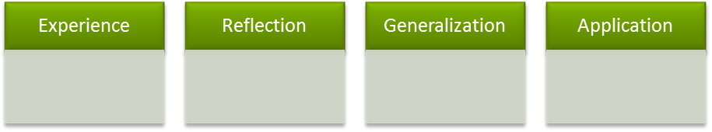

What visuals will we use?

What is our backup plan?

